Wassam Hussain
Roll Number: FA24-BCS-131
Lab Assignment 1

Assignment Statement
Lab 1 — Semantic HTML Scaffold

Difficulty: Easy · Covers: Lectures 3–4 · Folder: lab-1/

Before you design your own CV in Assignment 1, practice the raw skeleton: build a semantic HTML5 skeleton (no styling required) for a generic e-commerce homepage — correct <header>, <nav> with at least 4 links, a <main> containing three <section>s (featured products, categories, newsletter signup), and a <footer> with at least three columns of links. Validate your HTML with the W3C Validator and include a screenshot of a clean validation result in your completion PDF.

Deliverables in lab-1/: index.html and your completion PDF.

Screenshots of the Finished Work

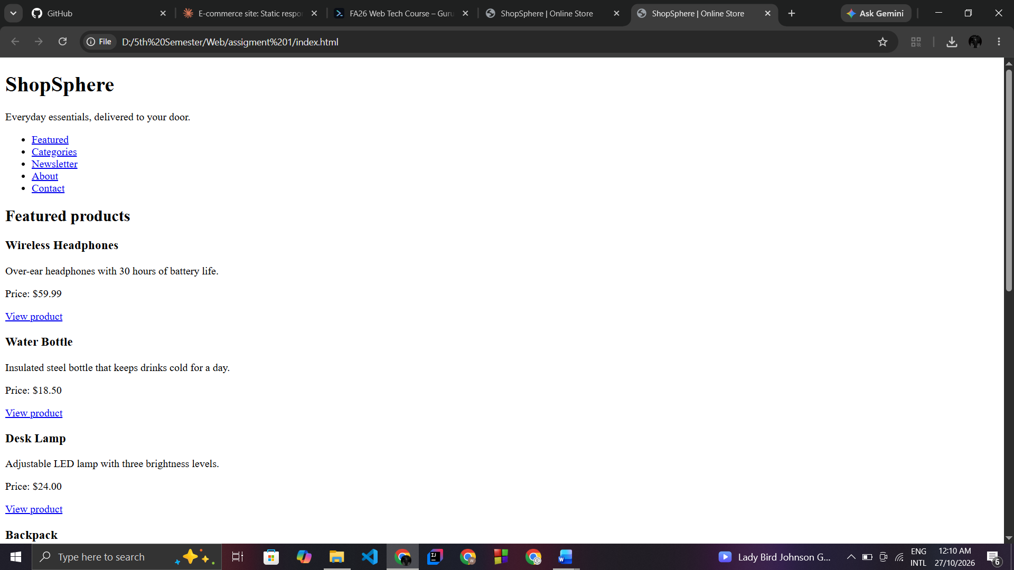

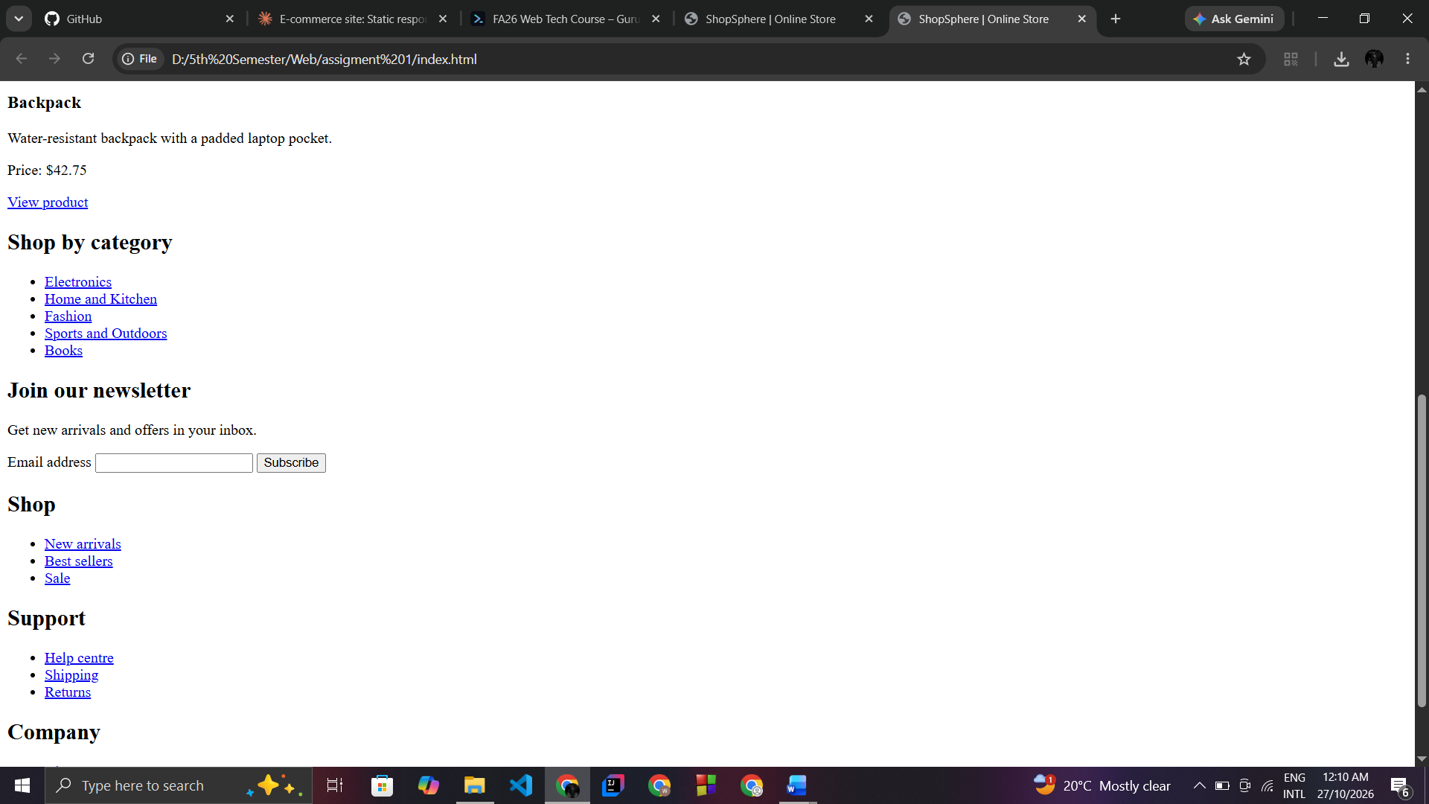

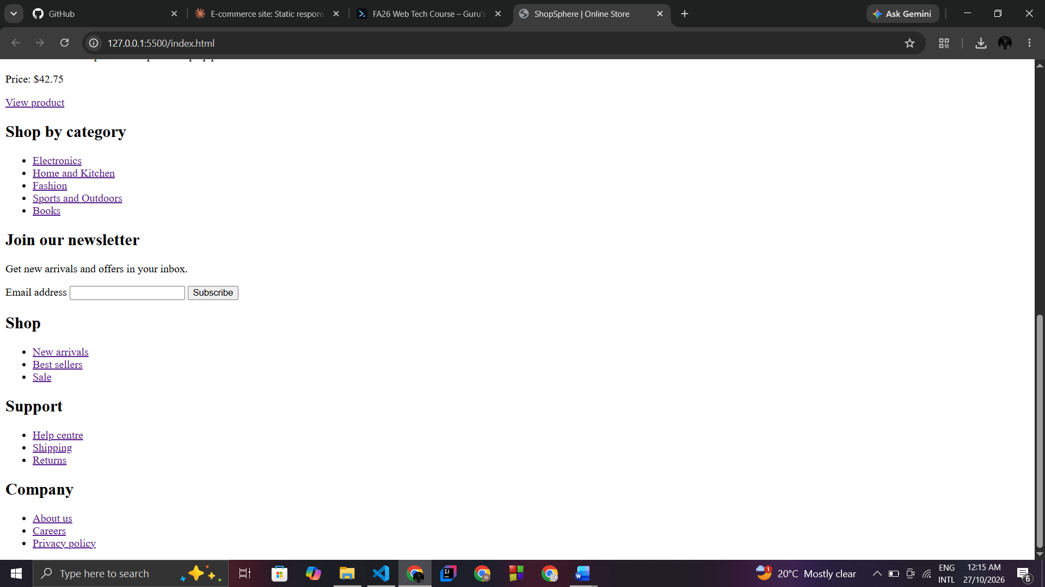

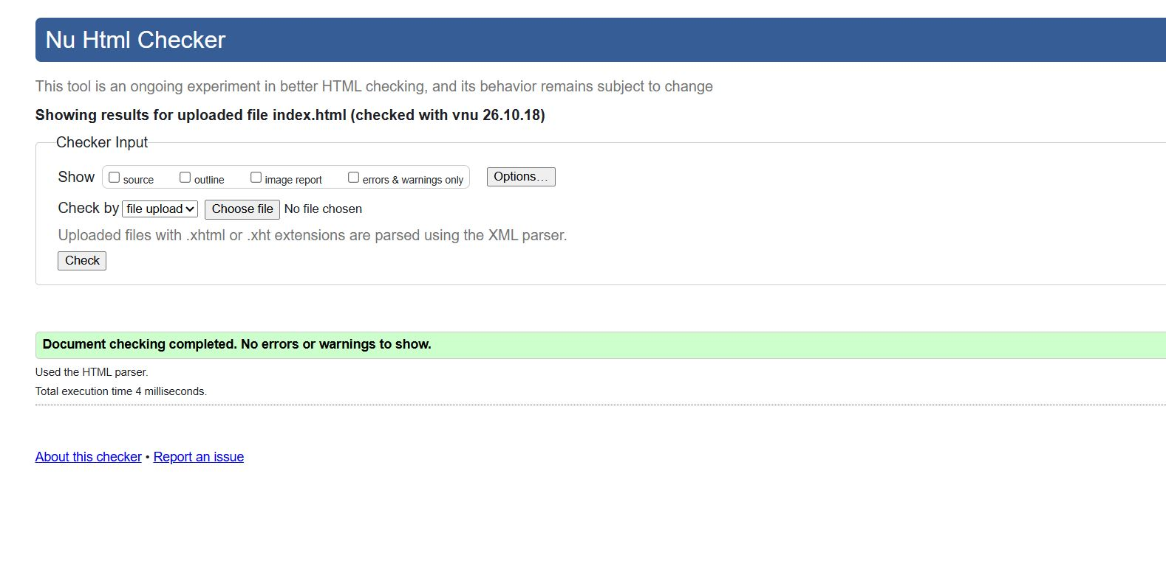

Code
<!DOCTYPE html>
<html lang="en">
<head>
<meta charset="UTF-8">
<meta name="viewport" content="width=device-width, initial-scale=1">
<title>ShopSphere | Online Store</title>
</head>
<body>
<header>
<h1>ShopSphere</h1>
<p>Everyday essentials, delivered to your door.</p>
<nav aria-label="Main navigation">
<ul>
<li><a href="#featured">Featured</a></li>
<li><a href="#categories">Categories</a></li>
<li><a href="#newsletter">Newsletter</a></li>
<li><a href="#">About</a></li>
<li><a href="#">Contact</a></li>
</ul>
</nav>
</header>

<main>
<section id="featured" aria-labelledby="featured-title">
<h2 id="featured-title">Featured products</h2>
<article>
<h3>Wireless Headphones</h3>
<p>Over-ear headphones with 30 hours of battery life.</p>
<p>Price: $59.99</p>
<a href="#">View product</a>
</article>
<article>
<h3>Water Bottle</h3>
<p>Insulated steel bottle that keeps drinks cold for a day.</p>
<p>Price: $18.50</p>
<a href="#">View product</a>
</article>
<article>
<h3>Desk Lamp</h3>
<p>Adjustable LED lamp with three brightness levels.</p>
<p>Price: $24.00</p>
<a href="#">View product</a>
</article>
<article>
<h3>Backpack</h3>
<p>Water-resistant backpack with a padded laptop pocket.</p>
<p>Price: $42.75</p>
<a href="#">View product</a>
</article>
</section>

<section id="categories" aria-labelledby="categories-title">
<h2 id="categories-title">Shop by category</h2>
<ul>
<li><a href="#">Electronics</a></li>
<li><a href="#">Home and Kitchen</a></li>
<li><a href="#">Fashion</a></li>
<li><a href="#">Sports and Outdoors</a></li>
<li><a href="#">Books</a></li>
</ul>
</section>

<section id="newsletter" aria-labelledby="newsletter-title">
<h2 id="newsletter-title">Join our newsletter</h2>
<p>Get new arrivals and offers in your inbox.</p>
<form action="#" method="post">
<label for="email">Email address</label>
<input type="email" id="email" name="email" required>
<button type="submit">Subscribe</button>
</form>
</section>
</main>

<footer>
<div>
<h2>Shop</h2>
<ul>
<li><a href="#">New arrivals</a></li>
<li><a href="#">Best sellers</a></li>
<li><a href="#">Sale</a></li>
</ul>
</div>
<div>
<h2>Support</h2>
<ul>
<li><a href="#">Help centre</a></li>
<li><a href="#">Shipping</a></li>
<li><a href="#">Returns</a></li>
</ul>
</div>
<div>
<h2>Company</h2>
<ul>
<li><a href="#">About us</a></li>
<li><a href="#">Careers</a></li>
<li><a href="#">Privacy policy</a></li>
</ul>
</div>
</footer>
</body>
</html>

